- Put all excel files to merge into one folder
- Export everything as a semicolon separated .csv using the provided converter (XLS to CSV Converter.hta)
- Move all .csv files in one folder. you can sort the files by ‘type’ to group them together
- Remove files you don’t want merged (morphospecies, empty sheets etc…) by sorting the .csv files by ‘size’ and removing the small ones
- Place the _combine.cmd file in the same folder as all .csv files
- Run it, it will take some time and close itself upon completion
- Transform the .csv file into a .xslx file
Because of the way our data is combined, the modern data query function of excel reports many errors, this isn’t very useful for us, so we import the data in the old-fashioned way:
  - On the newer version of Excel (anything newer than office 2016), enable the legacy text import options by following the steps here
On Older versions of Excel, you can just click “From text” in the “Data” tab
  - Locate the _combine.csv to import
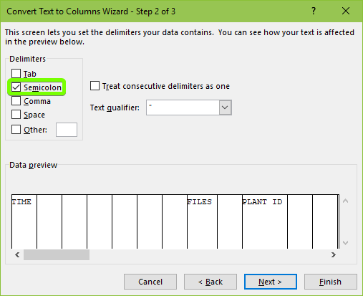
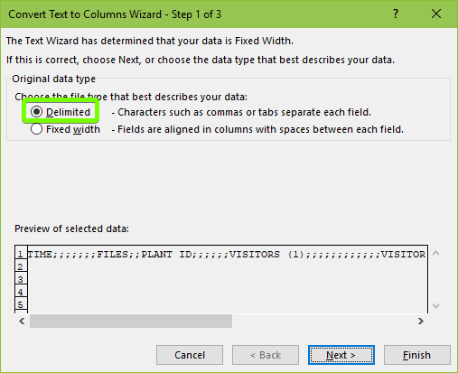
  - Set it up as indicated here, the windows might look different, just change what you see here:

  - Leave the last box as it is and click “Finish”
  - Save this as a .xslx file

- Clean up
  - Remove the 1st row
  - Set up a filter on the whole sheet and freeze the first row (if you don’t know how to do these things, google is your friend)
  - Delete the rows containing headers by filtering everything except one of the header names (e.g. “Year”) 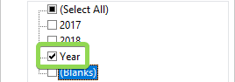
  - Go through all columns, checking the filter arrow if there are any weird values (e.g. wrong years, months, blank cells, errors, negative visit durations etc.) and fix these accordingly
    - Known issue: When column W had an error in original tables, the merged table could have removed some columns, shifting everything to the left so that visitors end up being under “Arrival” for example. Go back to the original tables and copy the data from there.
    - Known issue: When the insect orders weren’t filled out, a #REF error shows up in column Y, this could shift the rows one to the left, fix in original tables. Go back to the original tables and copy the data from there.
    - Known issue: Exclamation marks and ; in cells also cause errors
- Column structure
  - Remove redundant columns. This depends on you, but in our case it is: ##, Video file name, Video record present, Multiplier, T.o.A. in video file, T.o.D. in video file, ‘empty column before plant n°’, ‘another empty column before contacts’
  - Sort all records like this:
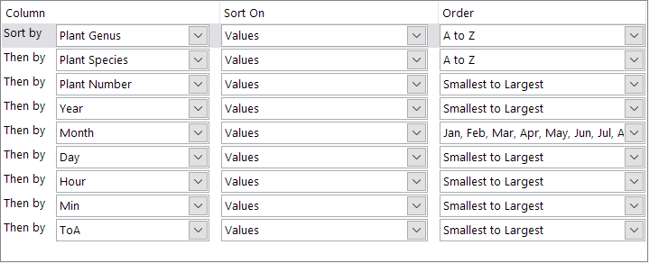
ID | PlantCode | Code on HDD | SpCode | Elev | Exp
  - Add 6 columns before “Year”:
  - Fill these accordingly:
    - ID: number from 1 to x with x being the last row of the table
    - PlantCode: used to identify individual plant, in our case we concatenate “SpCode”, “Plant number” and “Exp”. Write this formula in the PlantCode column (cel B2): =UPPER(LEFT(M2,3)&LEFT(N2,3)&O2&"_"&F2&"_"&E2)
    - Code on HDD: this is the code as written on the folder containing video files
    - SpCode: is the 6-character code used to identify a plant species, this can differ from “Code on HDD” because of corrections in plant identification
    - Elev: elevation
    - Exp: expedition number
  - Add a column before R: Total #obs: This is to add male and female flowers. Copy the formula
  - Fill the “any contact” column with =IF(OR(AS2=1,AU2=1)=TRUE,1,"")
  - Remove all #VALUE!, #REF! and #N/A! errors (the ‘!’ got removed by the merge)
  - And finally, doublecheck it all
- Clean the visitors
  - Functional group names, R is case-sensitive, they need to be exactly the same everywhere. Check with master files of other elevations. 1st letter in CAPS, everything else lowercase
  - Insect orders: split up as
    - Lepidoptera
      - lepidoptera (moth)
      - lepidoptera (butterfly)
      - lepidoptera (sphingid)
      - lepidoptera (larva)
    - diptera:
      - diptera – hoverfly
      - diptera - unsp
    - hymenoptera
      - hymenoptera – ants
      - hymenoptera – bee
      - hymenoptera - eusocial bee (bombus + apis)
      - hymenoptera - unsp.
      - hymenoptera - wasps (parasitoids)

FORMULAS to use in 2nd row
In this case: Column C -> PlantCode
Column E -> SpCode
Column G -> Elevation
Column H -> Season (WET or DRY)
Column M -> Minutes
Column U -> Total #obs flowers

Column W: First use: =IF(M3=M2, 1, "") -> indicate duplicate minutes
After calculating total rec. time (Column X), changes to: =IF(M3=M2, U2, "")
-> indicate duplicate flower minutes
Column X: =COUNTIF(C:C, C2)-SUMIF(C:C, C2, W:W)
-> calculate #minutes in the recording
Column Y: =SUMIF(C:C, C2, U:U)-SUMIF(C:C, C2, W:W)
-> calculate flower minutes in the recording per individual plant
Column Z: =SUMIFS(U:U, E:E, E2, H:H, H2)-SUMIFS(W:W, E:E, E2, H:H, H2)
-> calculate flower minutes in the recording per plant species per season per elevation
Column AA: =SUMIFS(U:U, E:E, E2, G:G, G2)-SUMIFS(W:W, E:E, E2, G:G, G2)
-> calculate flower minutes in the recording per plant species per elevation
Column AB: =SUMIFS(U:U, E:E, E2)-SUMIFS(W:W, E:E, E2)
-> calculate flower minutes in the recording per plant species across all elevations and seasons
If this is slightly confusing, essentially the steps to follow in this part are:
- Create six columns after “Visitor arrival”. Label them in order as:
- Duplicate minutes
- Recording time
- Flower minutes
- FM per SP
- FM per SP per EL
- FM per SP across all EL and SEAS
- Enter the formulae as above
- Copy paste formula for duplicate minutes
- Copy paste formula for flower minutes
  - Copy the values in this column and pastes as values only
- Rename the duplicate minutes column to duplicate flower minutes
- Copy paste the formula for duplicate flower minutes into this column
- Follow the rest of the steps as above.
CHECK DATA AGAIN
Once you have calculated everything, recheck the values for errors. Manually go through all column filters through the dropdown menu and see if there are #VALUE! Errors. Resolve these by tracing the source of the errors, use “trace precedents” and error checking options if needed.

Faster calculation (Using pivot tables, but more prone to errors!!! KNOW PIVOTTABLES and VLOOKUP or Index/match before use)
In this case: Column C -> PlantCode
Column E -> SpCode
Column G -> Elevation
Column H -> Season (WET or DRY)
Column M -> Minutes
Column U -> Total #obs flowers

Column W: -> indicate duplicate flower minutes
First use: =IF(M3=M2, 1, "") -> indicate duplicate minutes
After calculating total rec. time (Column X), changes to: =IF(M3=M2, U2, "")
Column X: -> calculate #minutes in the recording excluding duplicates
Make a pivot table: Row: PlantCode. Values: Count of Plantcode + Sum of Column W
Copy table and subtract the count of plantcode with Sum of column W
In Column X use vlookup: =VLOOKUP(C2,Sheet1!J$1:M$212,4,FALSE):
- Sheet1!J$1:M$212 Is the location of the table with the calculated recording time per species,
- 4 is the column number in which the final values are written and
- FALSE means you want an exact match.

Finally, replace the formula in Column X with the value (Copy & paste as values)

Column Y: -> calculate flower minutes in the recording per individual plant
After calculating total rec. time (Column X), changes to: =IF(M3=M2, U2, "")
Make a pivot table: Row: PlantCode. Values: Sum of U (Total observed flowers) + Sum of Column W (dups)
Copy table and substract the Sum of U with Sum of column W (total number minus duplicates)
In Column Y use vlookup: =VLOOKUP(C2,Sheet1!J$1:M$212,4,FALSE)

Finally, replace the formula in Column Y with the value (Copy & paste as values)

Column Z: -> calculate flower minutes in the recording per plant species per season per elevation
Concatenate a new column =CONCAT(E2,”_”, G2”,”_”,H2)
Make a pivot table: Row: NEW COLUMN. Values: Sum of U (Total observed flowers) + Sum of Column W (dups)
Copy table and substract the Sum of U with Sum of column W (total number minus duplicates)
In Column Z use vlookup: =VLOOKUP(NEWCOLUMN,Sheet1!J$1:M$212,4,FALSE)

Finally, replace the formula in Column Z with the value (Copy & paste as values)

Column AA: -> calculate flower minutes in the recording per plant species per elevation
Concatenate a new column =CONCAT(E2,”_”, G2”)
Make a pivot table: Row: NEW COLUMN. Values: Sum of U (Total observed flowers) + Sum of Column W (dups)
Copy table and substract the Sum of U with Sum of column W (total number minus duplicates)
In Column AA use vlookup: =VLOOKUP(NEWCOLUMN,Sheet1!J$1:M$212,4,FALSE)

Finally, replace the formula in Column AA with the value (Copy & paste as values)

Column AB: -> calculate flower minutes in the recording per plant species across all elevations and seasons
Make a pivot table: Row: SpCode. Values: Sum of U (Total observed flowers) + Sum of Column W
Copy table and substract the Sum of U with Sum of column W (total number minus duplicates)
In Column AB use vlookup: =VLOOKUP(C2,Sheet1!J$1:M$212,4,FALSE)

Finally, replace the formula in Column AB with the value (Copy & paste as values)

Add a column before Exact time of arrival -> Frequency
Frequency = Total number of flowers visited / flower minutes per species per elevation

EXCEL IS TOO SLOW?
The amount of data we are using here is too large for Excel’s computational capacities. Some things that you can do to bring this under control are:
- Switch off automatic calculation
- When you change a column that affects many others, it is best to clear the dependent columns and copy over the formula once more
- When filtering or manipulating the data for analysis, make a values-only copy of the excel file. This file loads and computes many times faster.

